BUSINESS TRANFORMATION WITH GENERATIVE AI: OPPORTUNITIES AND CHALLENGES

Submitted by

Muhammad Syafiq Bin Azrin (A0265532E)
Lee Jiaxin, Desiree (A0265554X)
Jason Lim Chee Loong (A0269824N)
Bushra Jahan (A0265563X)
Gerard Lim Wei Ren (A0265544Y)
Muhammad Afiq Bin Mohd Yusri (A0269822U)

Supervisor:
Wang Zhiguo

Examiner:
Aaron Chia

In partial fulfilment of the requirements for the
Degree of Bachelor of Technology
Industrial and Management Engineering

National University of Singapore
2024/2025
Executive Summary

This report presents the final outcomes and strategic direction of Skill Forge, a Generative AI (GenAI)-powered onboarding solution developed to address critical training challenges in the manufacturing sector. During the project’s initial scoping, two major industry pain points were identified: (1) the lack of effective, scalable onboarding for frontline workers, and (2) inefficiencies in predictive maintenance across manufacturing systems. This report focuses on the former., Workforce Training and Human–AI Collaboration, due to its immediate impact and strong alignment with Industry 5.0 priorities [5][10].

A working Skill Forge prototype was developed as a web-based GenAI training tool, integrating natural language interaction, multilingual support, and adaptive learning. In controlled evaluations with 30 participants, Skill Forge reduced average training time by 42% (60 → 35 minutes), increased knowledge retention to 88% (from 68%), and improved trainee confidence and satisfaction (from 3.2 → 4.6 and 3.5 → 4.8 respectively) [16].

A go-to-market strategy was also tested. A dedicated landing page, supported by a tiered pricing model, demonstrated early SME interest. Overall, Skill Forge achieved its objectives in training optimisation, AI personalisation, and adoption readiness—establishing a strong foundation for scalable deployment aligned with Industry 5.0.

Contents
1. Introduction 5
1.1 Background of Company 6
2. Problem Description 9
3. Methodologies and approaches 10
4. Comparison of design alternatives 13
5. Recommendations. Go-to-Market Strategy: Leveraging the Skill Forge Landing Page 14
5.1 Strategic Marketing Through the Landing Page 15
5.2 Proposed Pricing Plans and Target Audience 16
5.2.1 Target Audience 16
5.2.2 Pricing Alignment 17
5.2.3 Pricing Adjustments 17
6. Conclusion 17
References 19

1. Introduction
In recent years, manufacturers have been under increasing pressure to accelerate digital transformation and improve operational resilience [4]. Despite major investments in automation and analytics, one persistent barrier has been the reliance on outdated workforce training systems and manual knowledge-transfer processes. These traditional methods often result in inconsistent learning outcomes, prolonged onboarding periods, and limited adaptability among frontline workers. Simultaneously, many organisations have struggled to foster collaboration between human operators and AI-driven systems, which has impeded the broader adoption of emerging technologies [3].
At the outset of this project, two pressing manufacturing challenges were identified: (1) the inefficiency of current onboarding and workforce development practices, and (2) the fragmented implementation of AI in predictive maintenance. While both were significant, the project focused on the first challenge due to its clearer evaluation scope and its alignment with rising demands for human-centric digitalisation in manufacturing. This direction was further reinforced by global industry trends, particularly the shift towards Industry 5.0—a new paradigm introduced by the European Commission that emphasises meaningful collaboration between humans and intelligent systems [5].
Unlike Industry 4.0, which centred on automation and system integration [11], Industry 5.0 seeks to restore the human touch in production processes by promoting technologies that augment rather than replace human capabilities [10]. It promotes innovation that is sustainable, personalised, and socially inclusive. As illustrated in Figure 1.1, Industry 5.0 aims to deliver benefits such as improved safety, cost efficiency, competitive edge, accelerated upskilling, talent retention, and empowerment of workers.
To respond to these shifts, this report investigates the application of Generative AI (GenAI) as a transformative tool for frontline workforce development. Specifically, the study developed and evaluated SkillForge, a GenAI-powered onboarding prototype designed to deliver personalised training, improve knowledge retention, and boost productivity for small and medium-sized enterprises (SMEs). The subsequent sections outline the design rationale, technical implementation, evaluation results, and business implications of SkillForge in the context of Industry 5.0.
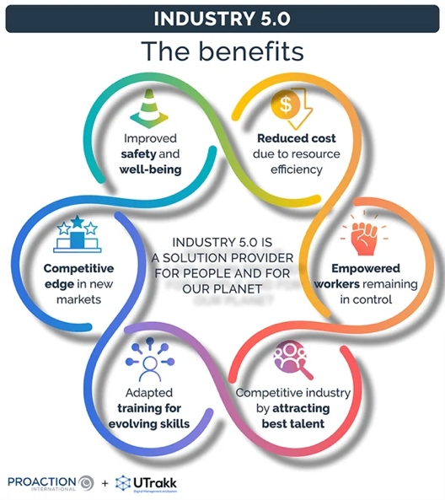
Figure 1.1: Industry 5.0 categories and benefits.

1.1 Background of Company
Skill Forge was conceived as a GenAI-driven solution provider targeting critical workforce development gaps within the manufacturing sector. It was developed with the specific aim of supporting small and medium-sized enterprises (SMEs)—a segment often overlooked in advanced technology adoption due to resource constraints, lack of technical talent, and slower digital transformation cycles [2]. These constraints create challenges in scaling consistent onboarding and training practices across multilingual, multi-generational workforces. Recognising this, Skill Forge focused on making AI-based training more accessible, adaptable, and scalable for SMEs engaged in manufacturing and related operations.

Unlike large enterprises that often possess internal learning and development teams or dedicated learning management systems (LMS), SMEs typically rely on static documents, informal shadowing, or time-consuming face-to-face briefings. These methods are often inconsistent, non-scalable, and do not adapt to the learning pace or background of individual workers. Skill Forge was positioned to solve this gap with an intelligent onboarding prototype powered by Generative AI (GenAI), delivering interactive, language-aware, and task-contextual learning—accessible on-demand via a simple web-based interface.

From its inception, Skill Forge aligned its development philosophy with the values and objectives of Industry 5.0—the next evolutionary step in industrial strategy. Unlike Industry 4.0, which prioritised system automation and interconnectivity, Industry 5.0 places the human at the centre of innovation, advocating for cooperation between people and machines, ethical AI usage, and sustainable production models [5][10].

The Skill Forge prototype was developed to embody these values through personalised learning pathways that adjusted to each worker’s language, experience level, and job requirements. Instead of displacing human trainers, AI was deployed to augment their efforts—providing round-the-clock support, multilingual explanations, quiz feedback, and even justifications for procedural steps via an “Explain Why” function. By blending explainable AI (XAI) with practical use cases, Skill Forge also helped workers build trust in AI tools—something that remains a barrier in many traditional factories [6].

As shown in Figure 1.2, Skill Forge represents a paradigm shift from prior industrial revolutions. While Industry 1.0 to 4.0 focused on mechanisation, electrification, automation, and digitalisation respectively, Industry 5.0 introduces the principle of personalisation—not just in product manufacturing, but in employee development and operational design. Skill Forge’s adaptive learning engine reflects this shift by dynamically tuning training content to the individual, enabling faster onboarding and higher skill retention rates. This human-centric design philosophy positions Skill Forge not only as a training tool but as an enabler of workforce resilience and industrial sustainability.
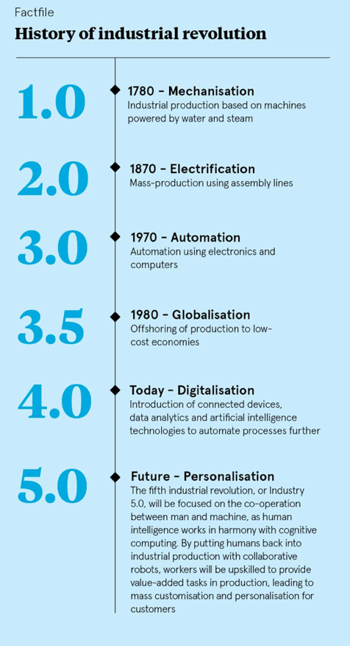
Figure 1.2: The history of industrial revolution.

2. Problem Description
Despite the increasing presence of artificial intelligence (AI) in manufacturing, the application of Generative AI (GenAI) remained significantly underutilised in workforce training and operational contexts [10]. GenAI presents transformative potential beyond conventional rule-based systems, offering capabilities such as real-time contextual assistance, synthetic data generation, and adaptive training simulations tailored to individual learners. However, several challenges hindered its widespread deployment across the sector, particularly among small and medium-sized enterprises (SMEs).
One key challenge was the absence of structured implementation frameworks. While traditional AI systems rely on fixed logic and rule sets, GenAI produces flexible, context-sensitive outputs that demand human interpretation and oversight. This characteristic introduces uncertainty for manufacturers, as the validation of GenAI-generated outputs, especially in safety-critical or compliance-driven environments, remained difficult to standardise. Without robust frameworks to ensure accuracy, explainability, and clearly defined human-in-the-loop roles, GenAI risked being relegated to experimental use with limited operational impact [4].
Scalability and accessibility posed further barriers. SMEs, unlike larger corporations, often lacked the technical expertise, budget, and infrastructure to adopt or experiment with AI tools. A study of Nordic SMEs highlighted the perception that GenAI required high up-front costs and technical maturity that smaller manufacturers could not afford [2]. Moreover, the return on investment (ROI) from AI-driven training solutions remained unclear for many business owners, especially in fields like precision engineering where operational downtime could not be risked. Without cost-effective, low-maintenance, and easily deployable solutions, GenAI adoption among SMEs remained limited.
A third constraint was workforce readiness. Most AI deployments in manufacturing had focused on automation and predictive analytics, with little emphasis placed on human–AI collaboration. Frontline workers and supervisors were often unfamiliar with how to interpret AI-generated feedback or interact with AI tools confidently. This lack of AI literacy, combined with cultural scepticism, presented a significant challenge to implementation. Furthermore, there was limited empirical research on how to embed GenAI meaningfully into existing training processes [16].
In light of these challenges, the Skill Forge project was conceived to design and evaluate a GenAI-powered onboarding system tailored for manufacturing SMEs. The aim was to demonstrate how AI could not only accelerate training and improve retention but also build trust through explainable outputs and adaptive content delivery. By benchmarking Skill Forge’s performance against traditional onboarding methods, the project sought to establish a structured, scalable, and contextually grounded framework for GenAI integration in industrial learning environments.

3. Methodologies and approaches
To explore the practical potential of Generative AI in enhancing workforce training, this project employed a literature-informed, design-driven methodology that focused on delivering both a functioning prototype and a replicable deployment model. The goal was not only to test technical feasibility, but also to understand how GenAI could be responsibly and effectively integrated into SME onboarding practices.
The core output of this project was the development of Skill Forge, a GenAI-powered onboarding platform tailored for the manufacturing sector. Informed by an extensive review of academic and industry literature (see Appendix A), the solution was designed to simulate real-world industrial training scenarios while maintaining accessibility for non-technical users. It included user-adaptive features such as skill-level detection, content personalisation, multilingual capabilities, and real-time contextual feedback. For instance, new operators interacting with the system received guidance in natural language, complete with justifications for actions and embedded explanations to deepen understanding.
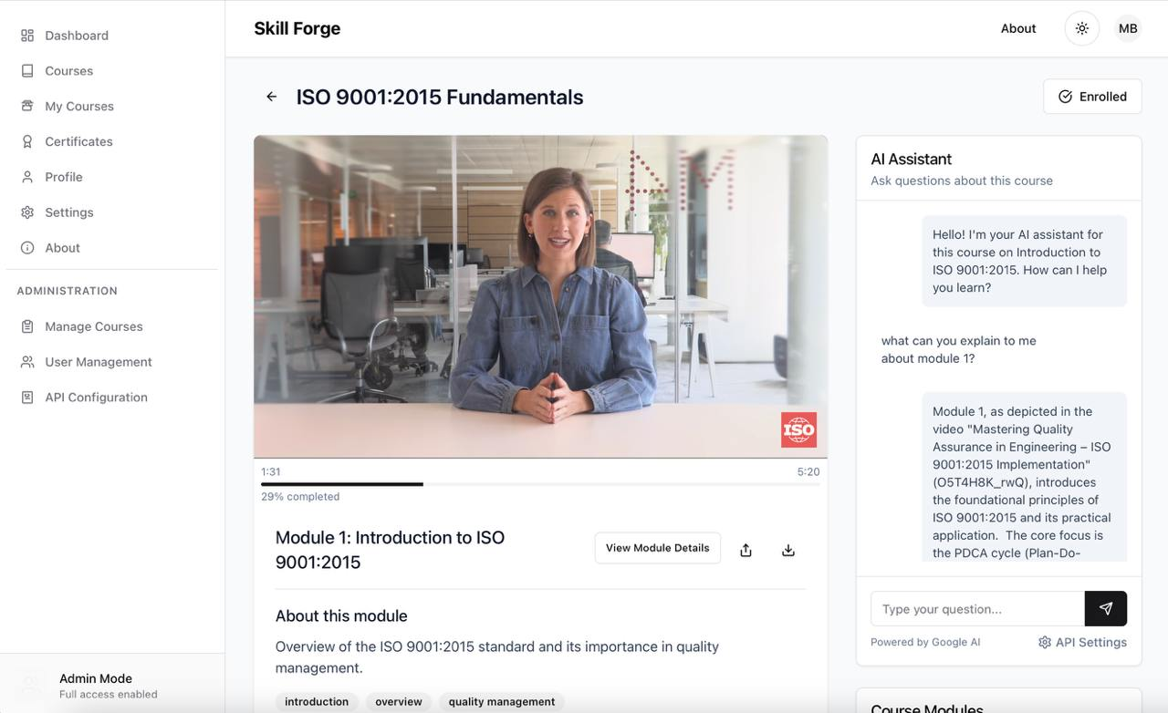
Figure 3.1: Screenshot of Skill Forge platform, showcasing interactive AI assistant embedded into training module.
To support personalisation and framework standardisation, the system architecture incorporated four key components: user profiling, contextual task assistance, AI-generated quizzes, and explainable feedback. Together, these elements facilitated a training pipeline that balanced automation with human oversight. AI acted not as a replacement for instructors, but as a tutor and collaborator—supporting just-in-time learning while reinforcing understanding through dynamically generated assessments.
Particular attention was paid to the barriers faced by SMEs, including limited technical manpower and budget constraints. In response, Skill Forge was built with lightweight deployment in mind. The platform was deployed as a web application requiring minimal setup. No specialised hardware or on-premises infrastructure was necessary, allowing immediate use from any internet-enabled device. The interface was deliberately designed for ease of use, offering multilingual options and a clean layout accessible to operators with little prior exposure to digital learning tools.
In addressing the issue of AI literacy and cultural resistance, the solution integrated explainability into its interactions. AI responses included “Explain Why” options that provided reasoning behind recommendations, helping workers build confidence and understanding over time. Early user tests suggested that this transparency was a key factor in encouraging trust and willingness to engage.
Finally, to assess market interest and support scalability beyond the prototype stage, a dedicated Skill Forge landing page was developed as part of the project’s go-to-market strategy. This digital channel served both as a promotional asset and an analytics platform to monitor visitor interest and user behaviour. By combining technical deployment with real-world stakeholder engagement, the methodology ensured that the project addressed not just technical innovation but also business viability and adoption readiness.w

4. Comparison of design alternatives
To evaluate the effectiveness of the proposed GenAI solution, a comparative benchmarking study was conducted with a single group of thirty participants. Each individual underwent two onboarding sessions: the first delivered through traditional methods comprising printed materials and human-led briefings, and the second using the Skill Forge GenAI-powered platform. After each session, participants completed a standardised evaluation that assessed key indicators including clarity of instructions, speed of learning, knowledge retention, confidence in applying learned skills, and overall satisfaction.
Short practical tasks were also incorporated to assess how well participants could apply what they had learned. This within-subjects design enabled a direct comparison of learning outcomes, minimising variance due to prior knowledge or differing experience levels. The results are summarised in Table 4.1.
Metric | Traditional | GenAI-based
 | 60 mins
  Training Time
  35 mins
Confidence | 3.2/5
  4.6/5
  Satisfaction
  3.5/5
  4.8/5
  Retention
  68%
  88%
Table 4.1: A table comparing Training Time, Confidence Score, User Satisfaction and Retention.
The GenAI-based system significantly outperformed traditional methods across all categories. Participants completed training approximately 42% faster with Skill Forge. Reported confidence in applying the acquired skills improved from 3.2 to 4.6, while satisfaction scores increased from 3.5 to 4.8. Most notably, average knowledge retention improved from 68% to 88%, consistent with findings from studies highlighting the value of interactive and personalised digital learning environments [16], [6].
These findings aligned with the broader literature on self-regulated learning and human–AI collaboration. Sitzmann and Ely [16] found that learners who received immediate feedback and adaptive support demonstrated significantly greater retention and engagement. Similarly, recent work in AI-enabled education systems has shown that context-aware prompts and personalised pathways contribute to improved user experience and learning efficiency [18], [7].
Qualitative feedback gathered post-training also indicated a higher sense of autonomy and reduced cognitive friction when using the AI interface. Participants appreciated the ability to ask follow-up questions and receive just-in-time clarifications, a capability absent in conventional training approaches. For example, several users highlighted the multilingual function and the “Explain Why” feature as particularly useful for improving understanding and trust.
Taken together, these results offer compelling evidence that GenAI-powered systems such as Skill Forge can enhance onboarding effectiveness, especially in environments where traditional training methods are resource-intensive or inconsistent. The data also reinforce the system’s alignment with Industry 5.0 objectives, where human empowerment and intelligent assistance are central to future-ready industrial operations.

5. Recommendations. Go-to-Market Strategy: Leveraging the Skill Forge Landing Page
Skill Forge was designed not only as a technical proof-of-concept but also as a commercially viable product targeting the manufacturing industry, with particular focus on the small and medium-sized enterprise (SME) segment. Recognising that GenAI adoption in traditional industries is often hindered by cost sensitivity, limited technical expertise, and unclear return on investment (ROI), a deliberate go-to-market (GTM) strategy was developed. This strategy is anchored by a public-facing landing page that showcases the product’s core features, cost-saving potential, and usability.

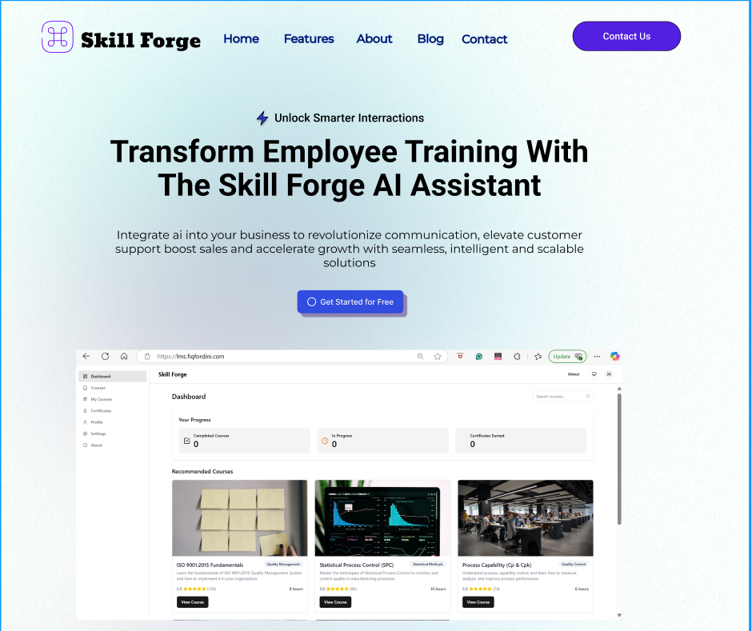
Figure 5.1: Snapshot of the Landing Page User Interface.

5.1 Digital Outreach via Skill Forge Landing Page
The Skill Forge landing page serves as the centrepiece of customer engagement. It was structured to communicate clear value propositions and to convert visitors into trial users. The design highlights benefits such as a 42% reduction in training time, 88% retention improvement, and multilingual AI assistant support, all of which were derived from empirical findings in Section 4.

Key elements included:
- Product Walkthroughs: Screenshots, demo videos, and testimonials to help potential clients visualise the platform in use.
- Lead Capture Mechanisms: Contact forms and demo request fields to gather trial user information.
- Pricing Visibility: Transparent pricing plans structured around SME affordability.

Marketing Strategy:
- Search Engine Optimisation (SEO): Keywords like “AI onboarding solution for factories,” “digital training for SMEs,” and “smart factory training tool” were targeted to attract organic traffic from relevant business searches.
- Google and LinkedIn Ads: Sponsored ads directed at decision-makers in manufacturing (e.g., Plant Managers, Training Heads) were recommended to drive traffic and gather interest from niche verticals.
- Partnership Announcements: The landing page contains a blog section for industry updates and collaboration news (e.g., partnerships with the Singapore Manufacturing Federation), building credibility.
5.2 Targeted Tiered Pricing Plans
The project’s user research and benchmarking highlighted how resource limitations affect digital adoption among SMEs. To address this, Skill Forge offers a three-tier subscription model tailored to different company sizes and training capacities. Pricing was set in reference to typical workshop budgets and training programme costs reported in SME studies [1][8].
5.2.1 Target Audience
Our primary audience is SMEs (10–50 employees), such as small factories, which face resource constraints and high costs (Section 2). Larger firms (e.g., Siemens, Tesla) with over 200 employees are a secondary target, benefiting from scalability.
- SMEs (Standard Plan: $129/month): Small manufacturers needing affordable, easy-to-use solutions.
- Mid-Sized Firms (Standard Plus Plan: $279/month): Manufacturers (50–200 employees) needing analytics and priority support.
- Large Enterprises (Deluxe Plan: $199/month): Multinational firms requiring API access and scalability.
5.2.2 Pricing Alignment
The pricing addresses scalability and accessibility challenges (Section 2). The Standard Plan ($129/month) offers SMEs an affordable entry with a free trial, covering 50 users. The Standard Plus Plan ($279/month) provides mid-sized firms with analytics to track outcomes (e.g., 88% retention, per Table 1). The Deluxe Plan ($199/month) includes API access for large firms but should be adjusted to $399/month to reflect its premium features and avoid confusion.
5.2.3 Pricing Adjustments
We propose a freemium model (e.g., 10 users, basic AI chat) to lower SME entry barriers, promoted on the landing page (“Try for Free Forever”). Annual billing discounts (e.g., Standard Plan: $129/month to $116/month yearly) can further incentivise adoption.

6. Conclusion
The Skill Forge prototype successfully addressed the critical need for scalable, efficient, and personalised workforce onboarding within the manufacturing sector, aligning with trends in AI-driven innovation (SAP, 2024). By tackling the limitations of conventional training approaches, such as time intensity, high resource demand, and lack of adaptability, the solution offered a future-ready alternative aligned with the principles of Industry 5.0.
Through the integration of natural language processing, multilingual support, and customisable learning paths, Skill Forge enabled a human-centric training experience that bridged the gap between human workers and AI systems. This collaboration not only improved knowledge retention and reduced training time but also enhanced user confidence and operational readiness across varying workforce profiles.
The Skill Forge landing page, combined with a targeted pricing structure and audience-specific marketing, positions our GenAI onboarding prototype as a transformative solution for the manufacturing sector. By optimising the landing page for lead generation, addressing SME challenges through a freemium model and annual discounts, and tailoring messaging for each audience segment, we can drive awareness, capture qualified leads, and ensure successful adoption. These recommendations bridge the gap between GenAI’s potential and practical application, empowering manufacturers, especially SMEs, to achieve operational excellence through AI-driven innovation.
The project demonstrated how advanced onboarding tools could empower small and medium-sized enterprises (SMEs) to adopt digital innovations without heavy infrastructural investment. In doing so, Skill Forge laid the groundwork for a broader transition toward human-AI synergy in manufacturing, illustrating a viable pathway for organisations to meet evolving industrial demands with both technological efficiency and human empowerment at the core.

References
- 40FACTORY. (n.d.). How artificial intelligence optimizes employee onboarding. Retrieved from https://www.40-factory.com/en/blog/artificial-intelligence-optimizes-onboarding/

- Bughin, J., Hazan, E., Ramaswamy, S., Chui, M., Allas, T., Dahlström, P., Henke, N., & Trench, M. (2017). Artificial intelligence: The next digital frontier? McKinsey Global Institute. Retrieved from https://www.mckinsey.com/business-functions/strategy-and-corporate-finance/our-insights/artificial-intelligence-the-next-digital-frontier

- O’Toole, C., Schneider, J., Smaje, K., & LaBerge, L. (2020, October 5). How COVID-19 has pushed companies over the technology tipping point—and transformed business forever. McKinsey & Company. https://www.mckinsey.com/capabilities/strategy-and-corporate-finance/our-insights/how-covid-19-has-pushed-companies-over-the-technology-tipping-point-and-transformed-business-forever

- Deloitte. (2020). The future of manufacturing: Making things in a changing world. Deloitte Insights. Retrieved from https://www2.deloitte.com/us/en/insights/industry/manufacturing/future-of-manufacturing.html

- European Commission. (2021). Industry 5.0: Towards a sustainable, human-centric and resilient European industry. Publications Office of the European Union. Retrieved from https://op.europa.eu/en/publication-detail/-/publication/468a892a-5097-11eb-b59f-01aa75ed71a1/

- Global Trade Magazine. (2024, October 28). Onboarding New Hires with Generative AI. Retrieved from https://www.globaltrademag.com/onboarding-new-hires-with-generative-ai/

- Developing AI-powered training programs for employee upskilling and reskilling. (2024). Journal of Informatics Education and Research. https://doi.org/10.52783/jier.v4i2.903

- Aarstad, A., & Saidl, M. (2019). Barriers to adopting AI technology in SMEs (Louise Harder Fischer, Ed.; p. 86) [Thesis]. https://research-api.cbs.dk/ws/portalfiles/portal/60704162/790410_Aarstad_Saidl_Barriers_to_Adopting_AI_Technology_in_SMEs.pdf

- IBM. (2020). The value of training. IBM Training and Skills. Retrieved from https://www.ibm.com/training/value-of-training

- IBM. (2024, September 3). How is AI being used in Manufacturing. Retrieved from https://www.ibm.com/think/topics/ai-in-manufacturing

- Lee, J., Bagheri, B., & Kao, H. A. (2015). A Cyber-Physical Systems architecture for Industry 4.0-based manufacturing systems. Manufacturing Letters, 3, 18-23. DOI: 10.1016/j.mfglet.2014.12.001

- Nahavandi, S. (2019). Industry 5.0—A human-centric solution. Sustainability, 11(16), 4371. DOI: 10.3390/su11164371

- Netguru. (2025, April 14). AI in Manufacturing: Enhancing Production Efficiency. Retrieved from https://www.netguru.com/blog/ai-in-manufacturing

- Peres, R. S., Jia, X., Lee, J., Sun, K., Colombo, A. W., & Barata, J. (2020). Industrial artificial intelligence in Industry 4.0 - systematic review, challenges and outlook. IEEE Access, 8, 220121-220139. DOI: 10.1109/ACCESS.2020.3042874

- SAP. (2024, June 17). How manufacturers can best use generative AI. Retrieved from https://www.sap.com/austria/blogs/how-manufacturers-can-best-use-generative-ai

- Sitzmann, T., & Ely, K. (2011). A meta-analysis of self-regulated learning in work-related training and educational attainment: What we know and where we need to go. Psychological Bulletin, 137(3), 421-442. DOI: 10.1037/a0022777

- Wang, L., Gao, R., Váncza, J., Krüger, J., Wang, X. V., Makris, S., & Chryssolouris, G. (2019). Symbiotic human-robot collaborative assembly. CIRP Annals, 68(2), 701-726. DOI: 10.1016/j.cirp.2019.05.002

- Zawacki-Richter, O., Marín, V. I., Bond, M., & Gouverneur, F. (2019). Systematic review of research on artificial intelligence applications in higher education–where are the educators? International Journal of Educational Technology in Higher Education, 16(1), 1-27. DOI: 10.1186/s41239-019-0171-0dex

(Additional literature review and industry research are provided in Appendix A. Technical implementation details, including system architecture diagrams and code samples, are provided in Appendix C.)

Appendix A – Literature Review

Literature Review
This literature review underpins our investigation into the transformative potential of generative AI in manufacturing. In the context of our project, “Business Transformation with Generative AI: Opportunities and Challenges,” we sought to uncover how cutting‐edge generative AI can revolutionize manufacturing processes. To achieve this, we developed a multi-phase process that transformed an unstructured corpus from the OpenAlex repository into a structured 23-field dataset, suitable for detailed quantitative and qualitative analysis. We have omitted this portion from the interim report due to lower relevance compared to important features in the main report.
Overview of the Dataset
We began by downloading the complete dataset from the OpenAlex website using the query “AI in Manufacturing.” This approach yielded a total of 50,200 documents covering a wide range of publication types, including articles, books, book chapters, preprints, reports, reviews, and other formats (such as dissertations and editorials). Of these, 17,324 records contained abstracts, providing the substantive content required for our analysis.

Document Type | Count | Percentage
Article | 44031 | 87.72%
Books | 466 | 0.93%
Book Chapters | 1312 | 2.61%
Preprints | 356 | 0.71%
Reports | 306 | 0.61%
Reviews | 3422 | 6.82%
Others* | 301 | 0.60%
Total | 50194 | 100%
Table 1 – Distribution of Document Types from OpenAlex
* Others include dissertations, editorials, letters, and additional formats.

Classification | Count
No Abstracts | 32876
Contains Abstracts | 17324
Manufacturing Context | 8128
Not Manufacturing Context | 9196
Table 2 - Classification of Manufacturing Context by available abstracts
Literature Review Methodology
Our methodology evolved through several iterative stages, incorporating both automated pipelines and manual refinement. The complete workflow comprises nine major steps, detailed below.
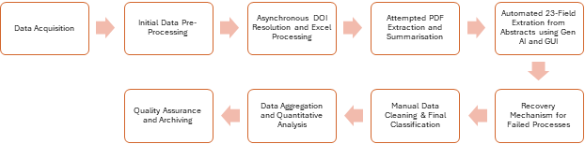
Figure 1 – Automated Literature Review
Step 1. Data Acquisition
We manually downloaded the full dataset from the OpenAlex website using the query “AI in Manufacturing.” This ensured that our dataset was comprehensive, encompassing 50,200 documents from diverse publication types.

Step 2. Initial Pre-processing
The full dataset was imported into a Pandas DataFrame using Python. During this phase, we filtered out records that lacked abstracts, reducing the dataset to 17,324 records. We also performed initial cleaning to remove non-relevant publication types and established basic classifications based on whether the document explicitly discussed manufacturing topics.

Step 3. Asynchronous DOI Resolution and Excel Processing
To enhance the dataset, we developed a Python script that processes an Excel file containing DOIs associated with the OpenAlex records. Using asynchronous processing with Python’s aiohttp and asyncio libraries, the script resolves each DOI. A Tkinter-based graphical user interface (GUI) was integrated to allow for file selection, real-time progress monitoring, and result saving. Robust error handling (with retries) ensured that failed resolutions were logged and managed appropriately.

Step 4. Attempted PDF Extraction and Summarisation
In parallel, we attempted to extract and summarise full-text content from PDFs linked to the resolved DOIs. We developed a separate Python pipeline that:
- Downloads PDFs asynchronously.
- Extracts text using PyPDF2; if text extraction failed, an OCR fallback (using pdf2image and pytesseract) was applied.
- Splits the extracted text into manageable chunks and summarises each chunk using an AI model.
Despite these efforts, the PDF extraction and summarisation process proved to be extremely time-consuming and computationally intensive, often taking multiple nights to complete. This led us to conclude that relying on the abstracts from the OpenAlex dataset would yield a faster turnaround and sufficient content for our purposes. Consequently, we did not proceed with the PDF extraction and summarisation for our interim report.

Step 5. Automated 23-Field Extraction from Abstracts
Recognising the efficiency of using abstracts, we developed a dedicated Python script to extract 23 structured fields from each abstract. These fields include qualitative aspects (e.g. “Use Cases,” “Opportunities,” “Challenges”) and categorical indicators (e.g. “Product Design & Innovation,” “Process & Production Optimisation”). Initially, we ran this extraction using LM Studio with the phi-3.1-mini-128k-instruct model, but processing times were excessively long due to limitations in hardware. We therefore transitioned to using Google’s gemini-1.5-flash-8b API, which reduced processing time from several nights to just a few hours on our Apple Mac Mini M4. The script automatically skips rows without abstracts and processes the remaining records concurrently via Python’s ThreadPoolExecutor, while a Tkinter GUI provides real-time progress feedback.

Step 6. Recovery Mechanisms for Failed Processes
Given the high volume of processing tasks, some API requests failed. We developed a recovery module that collates individually saved JSON responses from failed processing attempts and merges them with the main dataset. This ensured that any incomplete data were recovered and included in the final dataset.

Step 7. Manual Data Cleaning and Final Classification
After automated extraction, the aggregated dataset underwent a manual cleaning process. During this phase, we standardised field values, resolved inconsistencies, and further classified the documents by publication type and manufacturing context. We also applied additional thematic labels to highlight areas of strategic interest such as product innovation, process optimisation, quality control, supply chain management, workforce training, and sustainability.
Step 8. Data Aggregation and Quantitative Analysis
The manually cleaned and classified data were aggregated into a final comprehensive dataset comprising 23 fields per document. This structured dataset formed the basis for our quantitative and qualitative analyses. Key evaluation metrics, such as technical complexity, business transformation level, ROI impact, and time horizon were computed to assess the potential and challenges of AI driven transformations in manufacturing. For example, our evaluation metrics (summarised in Table 3) highlight that, while technical complexity and business transformation are generally rated as medium, many studies report an “unknown” ROI impact.
 | Low | Medium | High | Unknown
Technical Complexity | 187 | 5766 | 2175 | 0
Business Transformation Level | 472 | 6849 | 807 | 0
ROI Impact | 0 | 3192 | 780 | 4156
Implementation Risks | 187 | 5766 | 2175 | 0
Data Requirements | 187 | 5766 | 2175 | 0
 | Short-term | Medium-term | Long-term | Unknown
Time Horizon | 51 | 1751 | 6118 | 208
Table 3 – Evaluation metrics table

Step 9. Quality Assurance and Archiving
Throughout every stage, rigorous quality assurance measures were implemented. These included systematic error logging, automatic retries for failed API requests, and periodic saving of intermediate datasets.
Literature Review Interim Key Findings and Implications
Based on our analysis of structured metadata and AI generated insights through our workflow above, the following key themes emerged:
Category | Key Findings
Generative AI Adoption | Only 231 papers explicitly discuss Generative AI, but 673 papers indicate potential use cases where generative AI could be applied. This suggests that generative AI in manufacturing is still emerging, with broader AI adoption leading the way.
Primary AI Use Cases in Manufacturing | The most cited applications include process optimisation, predictive maintenance, defect detection, and digital twin technology.
Business Transformation Readiness | While 6,849 papers rate AI’s business transformation potential as medium, 807 papers classify it as high. However, 4,156 documents did not quantify ROI impact, indicating an industry-wide uncertainty in defining AI-driven business value.
Challenges in AI Deployment | The dataset highlights several recurring challenges: data silos, high technical complexity, and implementation risks. 5,766 papers rate technical complexity as medium, while 2,175 rate it as high. This suggests that even if AI is beneficial, its deployment requires overcoming integration barriers.
Explicit Generative AI vs. Broader AI | Only 187 papers explicitly focus on generative AI applications, while more than 8000 documents discuss traditional AI-based improvements. This suggests that while AI is already shaping manufacturing, the role of generative AI is still developing.
Table 4 – Key findings
Based on our findings, we could ask, “why does this matter? What insights can we derive from these findings that contribute to business transformation?” Here is how we address that:
Findings | Implication for Business Transformation
Generative AI in Manufacturing is Still Emerging | There is a gap between current AI adoption and the potential of generative AI, suggesting that there is an opportunity to guide businesses on best practices for generative AI deployment.
Process Optimisation & Predictive AI Dominate | Manufacturing firms prioritise efficiency-driven AI applications. Companies may hesitate to invest in generative AI due to unclear ROI and high technical complexity.
Uncertainty in Business Value (ROI) | The lack of clear ROI metrics (4,156 papers unknown) suggests that manufacturers may be hesitant to justify generative AI investment without more case studies. Future research should quantify business impact to drive adoption.
High Technical Complexity Slows Deployment | Businesses need strategic roadmaps for AI adoption, including phased rollouts and hybrid AI models that integrate generative AI with traditional AI systems.
Companies Need Tailored AI Strategies | Instead of a “one-size-fits-all” approach, companies must align AI adoption to their specific operational goals (e.g., quality control vs. supply chain management). This requires industry-specific frameworks.
Table 5 – Implication for business transformation
These implications suggest that businesses require more than just AI capabilities; they need clearer implementation frameworks, better ROI justifications, and strategies to overcome technical complexity.
Our findings from 17,324 research articles suggest that traditional AI techniques dominate manufacturing AI applications, whereas Generative AI remains underexplored. This presents a significant opportunity for businesses to innovate beyond conventional AI models and harness Generative AI’s ability to create, predict, and optimise industrial operations.
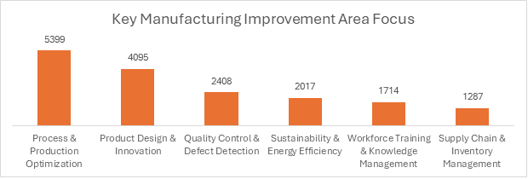
Figure 2 – Key manufacturing area focus
Key Manufacturing Area | Relevance to Generative AI
Product Design & Innovation | Generative AI can simulate new product concepts and automate iterative design modifications.
Process & Production Optimisation | AI-driven process simulations enhance efficiency, but Generative AI remains underutilised.
Quality Control & Defect Detection | Generative AI can generate synthetic defect datasets for training AI-driven inspection systems.
Supply Chain & Inventory Management | AI-powered forecasting is widely adopted, but Generative AI’s role is still emerging.
Workforce Training & Knowledge Management | Generative AI can enable adaptive, role-specific learning and decision support systems.
Sustainability & Energy Efficiency | Generative AI can optimise material usage and simulate environmentally friendly production methods.
Table 6 – Manufacturing and relevance to Generative AI

References:
[1] OpenAlex Repository

Appendix B – Survey Questions

Section 1: About Your Onboarding Experience (This question is just for categorization)
1. Onboarding Method:
A) Traditional / Manual
B) AI-Enhanced Program
Section 2: Experience Evaluation

A. Speed & Efficiency
1. Timeliness: “I was able to complete the onboarding modules in a reasonable amount of time.”
- Strongly Agree
- Agree
- Neutral
- Disagree
- Strongly Disagree
2. Prior Knowledge Adaptation: “The training allowed me to easily bypass topics I was already familiar with.”
- Strongly Agree
- Agree
- Neutral
- Disagree
- Strongly Disagree
B. Personalization & Adaptiveness
3. Self-Paced Learning: “I was able to progress at my own pace without unnecessary waiting or delays.”
- Strongly Agree
- Agree
- Neutral
- Disagree
- Strongly Disagree
4. Tailored Content: “The training experience addressed my individual learning needs effectively.”
- Strongly Agree
- Agree
- Neutral
- Disagree
- Strongly Disagree
C. Knowledge Retention
5. Clarity of Content: “I rarely needed to re-read or ask for clarification on the training content.”
- Strongly Agree
- Agree
- Neutral
- Disagree
- Strongly Disagree
6. Retention Effectiveness: “The training materials helped me retain information well.”
- Strongly Agree
- Agree
- Neutral
- Disagree
- Strongly Disagree
D. Productivity Impact
7. Reduced Dependency: “Post-training, I found I spent less time asking colleagues for assistance.”
- Strongly Agree
- Agree
- Neutral
- Disagree
- Strongly Disagree
8. Work Readiness: “I felt ready to contribute effectively to my work tasks shortly after the onboarding.”
- Strongly Agree
- Agree
- Neutral
- Disagree
- Strongly Disagree
E. Navigation & User Experience
9. Ease of Use: “The training system was intuitive and easy to navigate.”
- Strongly Agree
- Agree
- Neutral
- Disagree
- Strongly Disagree
10. Progress Tracking:
“The system effectively saved my learning progress and preferences.”
- Strongly Agree
- Agree
- Neutral
- Disagree
- Strongly Disagree
F. Overall Impact
11. Efficiency Comparison: “This onboarding method allowed me to become productive faster compared to other training experiences.”
- Strongly Agree
- Agree
- Neutral
- Disagree
- Strongly Disagree
12. Recommendation Likelihood: “I would recommend this onboarding approach to others.”
- Strongly Agree
- Agree
- Neutral
- Disagree
- Strongly Disagree
Section 3: Open-Ended Feedback
13. Key Strengths: “What do you consider the most useful or effective feature of this onboarding process?”
(Please provide as much detail as you feel comfortable sharing.)
14. Areas for Improvement: “Were there any challenges or limitations you experienced during the training? Please explain.”
15. Preference & Rational: “If given a choice in the future, which onboarding method would you prefer—traditional/manual or this current approach? Please explain why.”
16. Additional Feedback: “Is there anything else you would like to share about your onboarding experience?”

Appendix C – System Implementation & Technical Documentation for Skill Forge

File-tree & Technology Stack
SkillForge/
├── client/ # React frontend (TypeScript, Vite)
│ ├── src/
│ │ ├── components/ # Re-usable UI (Shadcn UI)
│ │ ├── hooks/ # Custom React hooks
│ │ ├── lib/ # Utils (Zod, Axios)
│ │ ├── pages/ # Page-level components
│ │ └── providers/ # React context
│ └── index.html
├── server/ # Node 20 backend (TypeScript, Express 4)
│ ├── api/ # REST + LLM adapters
│ ├── auth.ts # Passport auth
│ ├── db.ts # Drizzle ORM / Neon
│ ├── gemini.ts # Google Gemini wrapper
│ ├── routes.ts # Route registration
│ ├── vector-db.ts # Chroma embeddings
│ └── ratelimiter.ts # Rate-limit middleware
├── shared/ # Shared types & schema
│ └── schema.ts
└── .config/ # Vite build artefacts

Layer | Main libraries (exact versions)
Frontend | react 18.3.1; vite 5.2.4; tailwindcss 3.4.1; @tanstack/react-query 5.60.5; shadcn/ui
Backend | express 4.21.2; passport 0.7.0; drizzle-orm 0.39.1; typescript 5.4.4
Vector DB | chromadb 2.0.1; @xenova/transformers 2.17.2; onnxruntime-node 1.21.0
LLM SDKs | @google/generative-ai 0.24.0; openai 4.89.0
Tooling | Node 20; PNPM 9; PostCSS 8

System Architecture
CLIENT
Browser → Vite Dev Server → React App (JWT in SameSite Strict cookie)
SERVER
Express API
├─ Auth middleware (passport-local, connect-pg-simple)
├─ API routes
│ ├─ /chat → Gemini wrapper (LLM Service)
│ ├─ /quiz → Quiz generator & scorer
│ └─ /analytics → Time-on-task logger
├─ Rate-limit (100 req / 15 min)
└─ Helmet + Compression
STORAGE
• Neon Postgres (Drizzle ORM)
• Chroma vector DB for embeddings
LLM
• Google Gemini Pro (primary)
• OpenAI (optional fallback)
Data-flow: React ⇆ Express ⇆ (Postgres / Chroma / Gemini)
All secrets via .env; HTTPS enforced in production.

Core Module Summaries with Key Snippets

server/index.ts
Bootstraps Express; mounts helmet, compression, logger, JSON body-parser and rate-limiter (100 req/15 min). Registers routes then starts HTTP on :5000.
import express from 'express';
import helmet from 'helmet';
import compression from 'compression';
import rateLimit from './ratelimiter';
import { registerRoutes } from './routes';
(async () => {
const app = express();
app.use(helmet());
app.use(compression());
app.use(rateLimit);
app.use(express.json());
registerRoutes(app);
app.listen(process.env.PORT ?? 5000);
})();

server/gemini.ts
Factory for Google Gemini with safety BLOCK_NONE. Provides generateText, chatCompletion and generateQuizQuestions helpers.
import { GoogleGenerativeAI } from '@google/generative-ai';
export const genAI = new GoogleGenerativeAI({
apiKey: process.env.GEMINI_API_KEY!,
safetySettings: { category: 'HARM_CATEGORY_DANGEROUS', threshold: 'BLOCK_NONE' }
});
export async function chatCompletion(messages) {
const model = genAI.getGenerativeModel({ model: 'gemini-pro' });
const { response } = await model.generateContent({ contents: messages });
return response.text();
}

server/api/quiz.ts
Generates 5 MCQs for a module, stores them, and scores submissions.
router.post('/:moduleId', async (req, res) => {
const module = await db.query.modules.findById(req.params.moduleId);
const questions = await generateQuizQuestions(module.content);
await db.insert(quizzes).values(questions);
res.json({ ok: true, questions });
});
router.post('/:id/submit', async (req, res) => {
const { answers } = req.body;
const quiz = await db.query.quizzes.findById(req.params.id);
const score = grade(quiz, answers);
if (score >= 0.8) await markComplete(req.user.id, quiz.moduleId);
res.json({ score });
});

client/src/components/chat/ai-assistant.tsx
Streams chat responses via Server-Sent Events (SSE); optimistic UI updates.
const handleSend = async () => {
setMessages(m => [...m, { role: 'user', content: text }]);
const resp = await fetch('/api/chat', { method:'POST', body: JSON.stringify({ text }) });
const reader = resp.body.getReader();
let buffer = '';
for await (const chunk of streamIterable(reader)) {
buffer += chunk;
setAssistantTyping(buffer);
}
setMessages(m => [...m, { role: 'assistant', content: buffer }]);
};

Research-Method Hooks & Instrumentation
User profiling / skill-level detection (shared/schema.ts):
export const modules = pgTable('modules', {
id: serial('id').primaryKey(),
title: text('title'),
skill: text('skill').$type<'Beginner'|'Intermediate'|'Advanced'>(),
tags: jsonb('tags').default([])
});
Dynamic prompt template (server/api/llm.ts):
const base = 'You are an expert educational assistant for a manufacturing LMS.';
const messages = [
{ role: 'system', content: base },
{ role: 'user', content: question }
];
Chat interaction logging:
await storage.createChatInteraction({
userId, courseId, moduleId, question, answer,
ts: new Date()
});
Time-on-task instrumentation in React:
useEffect(() => {
const start = Date.now();
return () => {
fetch('/api/analytics/time', {
method: 'POST',
body: JSON.stringify({ moduleId, ms: Date.now() - start })
});
};
}, [moduleId]);
Security & Ethics Audit

Aspect | Current state | Recommendation
Transport | Dev = HTTP; prod behind Nginx TLS | Enforce HTTPS, HSTS
Sessions | connect-pg-simple; cookies not Secure in dev | Secure:true; SameSite:Strict in prod
Rate-limit | 100 req / 15 min | Parameterise via env RATE_LIMIT_MAX
Secrets | .env file | Rotate quarterly; store in Vault
Data export | None | Add /me/export GDPR/PDPA endpoint

Environment variables required: GEMINI_API_KEY, OPENAI_API_KEY, DATABASE_URL, JWT_SECRET, RATE_LIMIT_MAX, PORT.
Passwords hashed with bcrypt 12 rounds; other PII stored plaintext.

Appendix D – Landing Page UI

A Design of our planned landing page UI using Figma software.

- https://www.figma.com/proto/3wNNEr88o0FDVYlCw0G2HZ/Chatbot-Landing-Page-Draft-2?page-id=0%3A1&node-id=6-104&p=f&viewport=292%2C-302%2C0.13&t=5et5VadarLq2VTfb-1&scaling=min-zoom&content-scaling=fixed

